EATON HOUSE, IRELAND

Poesia mottled glass bricks are a contemporary interpretation of materiality at Eaton House

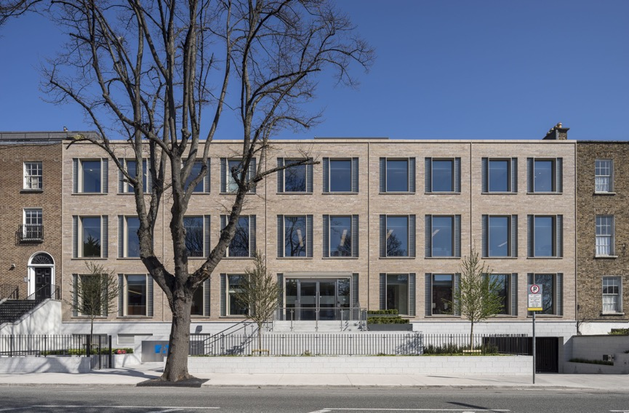

It was a substantial redevelopment of a 1960s office block in Dublin, creating the corporate headquarters for Eaton Corporation in Dublin.

Located at Balls Bridge in the historic D4 district, Eaton House sits more than comfortably in its context, enhancing the neighbourhood’s Georgian architecture, a melting pot of residences, small businesses, parks and embassies. The existing block is divided into two buildings of three and five storeys over a basement carpark and, as well as office space, includes boardrooms, catering facilities and external landscaping.

While still respectful of its historic context, Eaton House is designed to be a building of its time, delivering a contemporary re-interpretation of materiality and brickwork proportions, and window and door openings to the adjacent historic buildings. The facades of the original terrace houses on the block were organised based on the golden rectangle. So, the new facade of Eaton House reflects the original five terrace houses in its organisation, its clear glass openings also reflecting the original golden rectangle proportions.

The exterior façade is re-envisioned with linear coursed limestone, clear vision glass and the use of Poesia handmade mottled cast glass bricks at the sides of the windows.

To maintain the specific proportional composition, but introduce more daylight, the architects introduced cast glass into the facade composition after learning the durable material was historically integrated into pavements in the neighbourhood to bring daylight into basements. Poesia handmade the bricks to specific dimensions, coordinating with the proportions of the stone coursing dimensions so the mortar lines in the masonry facade translate uninterrupted into the window composition. The hand cast bricks are recessed against the clear glass openings, “respecting how the material was used historically to add more daylight and create a more open, productive work environment,” notes Pickard Chilton.

In fact, the addition of Poesia mottled glass bricks to the sides of the windows results in a 38% increase in daylight area over the building’s original façade:

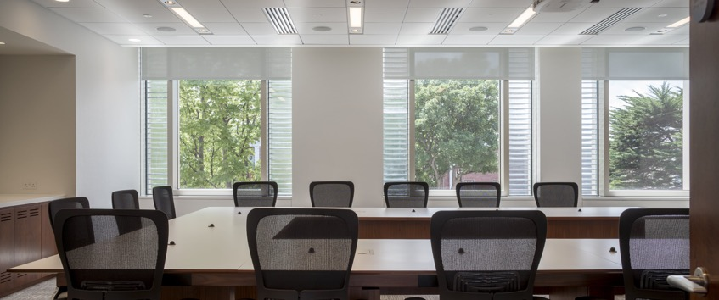

“With a high level of transparency, the cast glass brick creates a more open office environment and its dappling of sunlight adds visual interest to both the interior and exterior,” adds Pickard Chilton.

Poesia worked with the architects and the façade contractor creating a custom size solid glass brick with a mottled texture to match the proportions of the limestone (300mm x 75mm x 65mm). Poesia created custom moulds and supplied mock-ups for approval before production began. The solid glass bricks were installed using a glass brick mortar, a re-bar system inside the joint coursing, and expansion joints around the perimeter, which were polymer sealed.

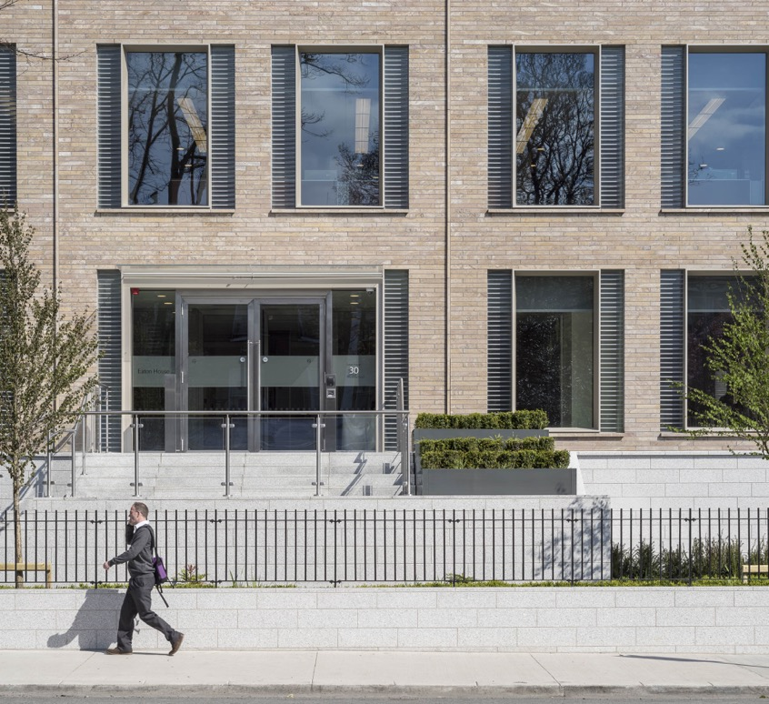
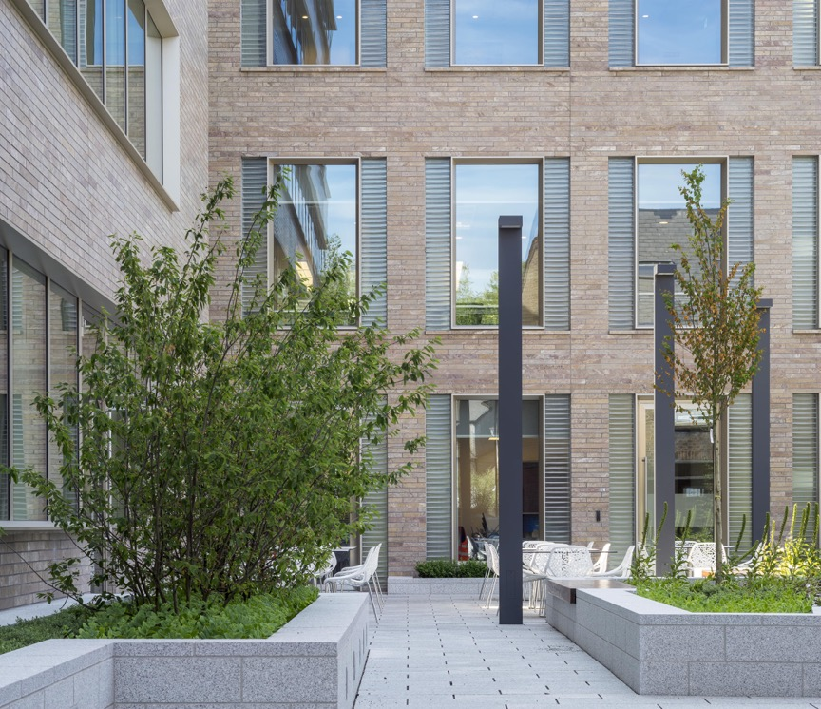

Rewardingly for the team, the Eaton House has won six awards, including:
• IA QUAD Design Award, Honor Award, 2017 .
• European Centre for Architecture, International Architecture Award, 2016.
• AIA Connecticut, Honor Award, Architecture: the Encompassing Art, 2016.
• AIA Europe Awards, Honorary Mention for Architectural Design, 2015.
• AIA Connecticut, Design Award, 2015.
• Marble Institute of America, Pinnacle Award of Merit, 2015.

Robertson’s Building Products is proud to be the exclusive Australian distributor for Poesia glass bricks. For more information on Poesia glass bricks, please visit our Glass Brick page or, better still, visit our showroom to see the full range of glass bricks available.

Design Architects: Pickard Chilton Architects
Executive Architects: MCA Architects
Developer: The Richard E Jacobs Group
Product: Handmade Cast Glass Bricks, Mottled
Structural Engineers: Barrett Mahony Consulting Engineers
M&E Engineers: Homan O’Brien
Interiors: NELSON
Contractor: John Sisk & Son
Images: Courtesy Poesia Studio

